USAID GLOBAL HEALTH SUPPLY CHAIN PROGRAM

Procurement and Supply Management

|  |
| --- |
| LaDATA (Logistic and Demographic Analysis for Targeted Action)  Using big data for targeted actions for the supply of Family Planning commodities  User Guide  January 2021 |

The USAID Global Health Supply Chain Program-Procurement and Supply Management (GHSC-PSM) project is funded under USAID Contract No. AID-OAA-I-15-0004.  GHSC-PSM connects technical solutions and proven commercial processes to promote efficient and cost-effective health supply chains worldwide. Our goal is to ensure uninterrupted supplies of health commodities to save lives and create a healthier future for all. The project purchases and delivers health commodities, offers comprehensive technical assistance to strengthen national supply chain systems, and provides global supply chain leadership.

GHSC-PSM is implemented by Chemonics International, in collaboration with Arbola Inc., Axios International Inc., IDA Foundation, IBM, IntraHealth International, Kuehne + Nagel Inc., McKinsey & Company, Panagora Group, Population Services International, SGS Nederland B.V., and University Research Co., LLC. To learn more, visit [ghsupplychain.org](http://www.ghsupplychain.org/)

DISCLAIMER:  
The views expressed in this publication do not necessarily reflect the views of the U.S. Agency for International Development or the U.S. government.

Contents

Contents 1

Acronyms 2

Overview of Dashboard 3

Using Dashboard with Stakeholders 3

Dashboard Log-In 4

Setting Demographic Indicator Threshold 6

For Stakeholder Meeting 6

Setting Demographic Indicator Priority 7

For Stakeholder Meeting 7

Logistics and Priority Dashboard 7

For Stakeholder Meeting and Independent Monitoring 7

Logistics and Priority Data 8

Historical Logistics Data (2019) 9

Demographic Parameters 11

Annex A. Data Sources 12

Demographic Data 12

Acronyms

|  |  |
| --- | --- |
| CYP  GHSC-PSM  LaDATA | couple years of protection  Global Health Supply Chain Program – Procurement and Supply Management  Logistic and Demographic Analysis for Targeted Action |
|  |  |
|  |  |
|  |  |
|  |  |
|  |  |
|  |  |
|  |  |
|  |  |
|  |  |
|  |  |
|  |  |
|  |  |
|  |  |

Overview of Dashboard

In 2020 Global Health Supply Chain Program – Procurement and Supply Management project (GHSC-PSM) developed a tool that enables users to make family planning prioritization decisions informed by both demographic and logistics data. Currently, program priorities may lack connection and coordination with supply chain actions and information and actions. The goal of this web application Logisitics and Demographic Analysis for Targeted Action (LaDATA) is to help users synchronize program priorities and drive coordinated actions based on demographic and logistics data.

The family planning priorities will be based on key demographic indicators, including total population, total number of pregnancies, family planning demand satisfied, unmet family planning needs, and use of modern family planning methods. By incorporating both sources of data, the goal of this web application is to promote transparent and consistent approaches to decision-making at the national level.

Using Dashboard with Stakeholders

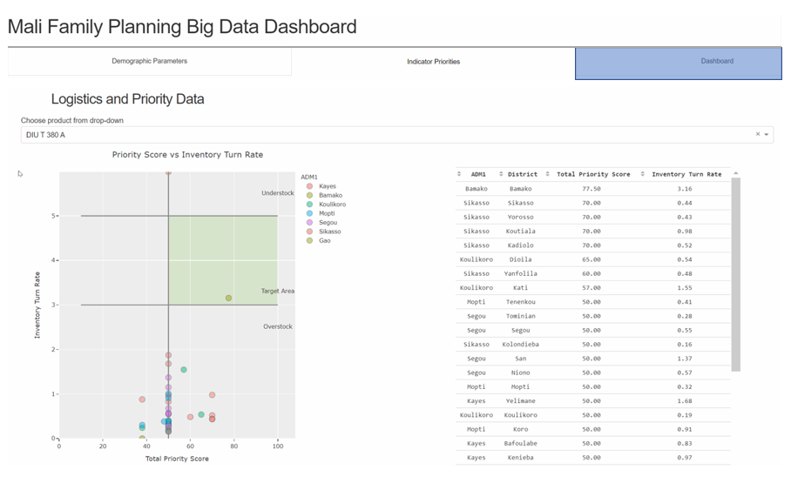

Figure 1: LaData Dashboard

The primary purpose of the dashboard is to support a stakeholders meeting on setting data-driven priorities and track actions over time. The users of the dashboard should collectively review indicator thresholds and ranking. This creates a transparent and a data-driven outcome that is consistent at the national level.

LaDATA is an analytic dashboard is built using [Dash](https://plotly.com/dash/), an open source python-based web application platform for automating data analytics and visualizing data in an interactive platform to enhance usability for decision-making using data.

The dashboard can be also used independently to explore trends in logistics data. In between user group sessions, the dashboard will support monitoring of any anomalies and track progress made through the current prioritization setup.

The stakeholders will begin by visiting whether current prioritization setup produces outcomes that are aligned with programmatic goals. If the scores need to be updated, the user group will review demographic data in the Demographic Parameters and Indicator Priorities tabs and decide on a reasonable threshold, as well as the indicator rankings. The composition of program priorities is not expected to change frequently. The histogram and data table will provide the distribution and descriptive statistics of the selected indicator. Coupled with the stakeholders’ expert local knowledge, thresholds and ranking can be updated. After updating the values, the dashboard will combine user input with logistics data from LMIS to show which districts are prioritized, and what the distribution patterns looks like. The dashboard also presents the user group with historical trends. The stakeholder group can reference the dashboard to decide on what actions moving forward, they should take.

Adjustment of programmatic priorities is discouraged for individual use. Resetting the priorities will update the database entries and change the dashboard view. Additionally, priorities should only be adjusted if they do not align to program goals or misaligned from distribution data. This observation should be agreed upon and confirmed in a stakeholder engagement meeting.

Dashboard Log-In

When it’s first opened, the LaDATA application has includes basic authentication.

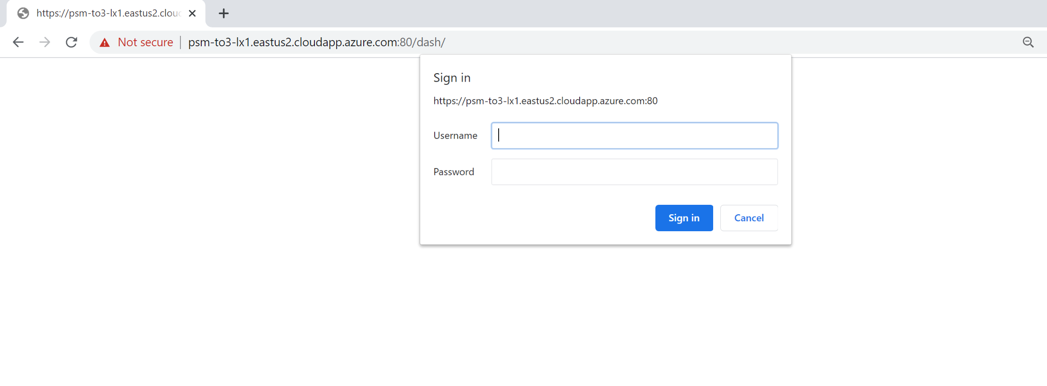

Figure 2. Dash application login page

After entering the username and password, the landing page opens at the default locations is on dashboard tab, with no data filled in, as shown in Figure 3. This is so that user can begin to use the dashboard with the current logistics data and priority input. The demographic parameters and indicator priority tabs are only needed for use in the stakeholder meetings to determine settings for the demographic parameters and the indictor priorities.

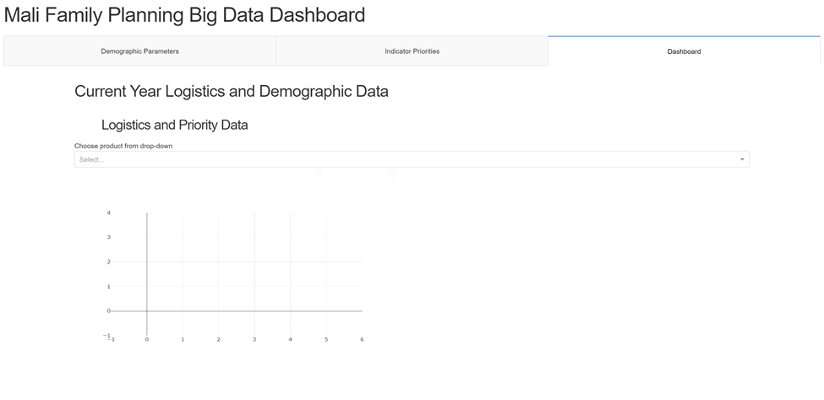

Figure 3. Landing page of Family Planning Big Data Dashboard

As such, the dashboard can be used independently outside of the stakeholder engagement meetings for purposes such as continuous tracking of logistics data and monitoring of action impact. The dashboard will pull the latest priority input from the database. Each of the charts in the dashboard can be downloaded as PNG images to a local computer.

# Setting Demographic Indicator Threshold

For Stakeholder Meeting

Should the stakeholder group decide to update the priority input, the first step is to navigate to the demographic indicator tab and review the thresholds. Inputs on this page will determine, for each indicator, what high, medium, and low values would be. In addition to the data table, this page has two visualizations to aid the understanding of demographic indicators. The data table shows the range and current thresholds. A histogram will show the distribution nationally by value; and a heatmap will show value distribution of the indicator selected by district. Depending on the distribution type, thresholds may be tighter or wider from the median value. For example, an indicator with a Gaussian-like bell curve should have different thresholds that is close to where data values may be concentrated, such as the medium-high threshold in Figure 4; whereas for a relatively uniform distribution, the low-medium and medium-high thresholds should be closer to the 25th and 75th percentiles. These low, medium, and high categories are meant to establish the point at which the demographic data of a region is out of the expected zone (high or low depending on the indicator), and ultimately contributes to which regions will be flagged for action.

For each demographic indicator, the user can click on the radio button to view the national distribution. Figure 4 shows an example of selecting pregnancies per 1,000 women. To change the low-medium value threshold, double click the cell and update the values. The vertical line will automatically update when the user hits enter.

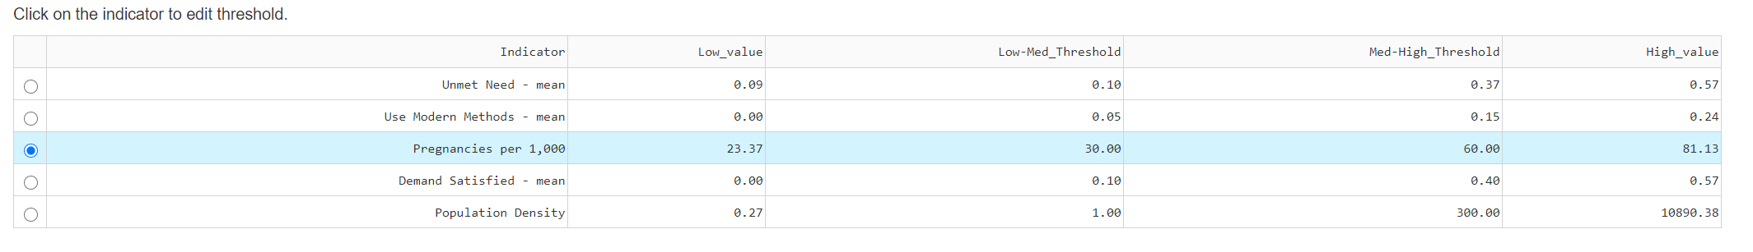

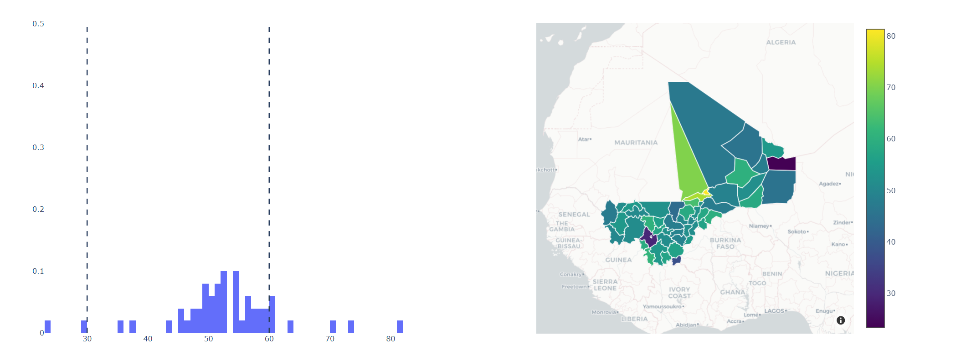

Figure 4. Demographic indicator selection with threshold

# Setting Demographic Indicator Priority

For Stakeholder Meeting

The second step is to adjust the indicator priority ranking. The key question to answer on this page is: “What should drive action?” Figure 5 shows the selections required from the user. On the left-hand side, the user ranks each of the indicator from highest to lowest in relative weight to drive action in supply chain. And then for each indicator, in that selection, the user decides what level should be prioritized. If High is selected for Priority 1, then based on the threshold set forth in the previous page, a high level of that indicator will receive highest score. Taking the Unmet Need indicator as an example, selecting high means that districts with high unmet need will receive higher priority than those with lower values. On the contrary, for an indicator like demand satisfied, we may choose low values as receiving more attention for actions needed than high values. Recall that the high and low values are determined by the threshold values in the previous tab.

2. If high unmet need drives action, select high

1. Select indicator, for example unmet need, as priority 1

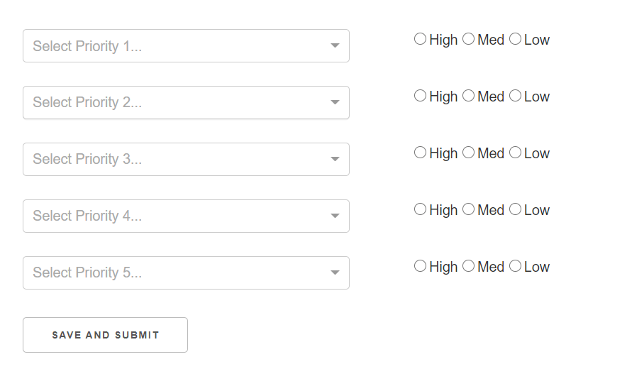

Figure 5. Ranking indicator by priority and selecting high priority values

Logistics and Priority Dashboard

For Stakeholder Meeting and Independent Monitoring

The dashboard tab contains visualizations in three areas: logistics and priority data, historical (2019) logistics data, and demographic indicators. Each area pulls from a different set of data. The user can interact with controls under each section to change the visualization.

Logistics and Priority Data

Visualizations in this section combine the current year (2020) logistics data with district-level priority score. The user selects a product to view from the drop-down list, which will filter the data for all the visualizations in the section.

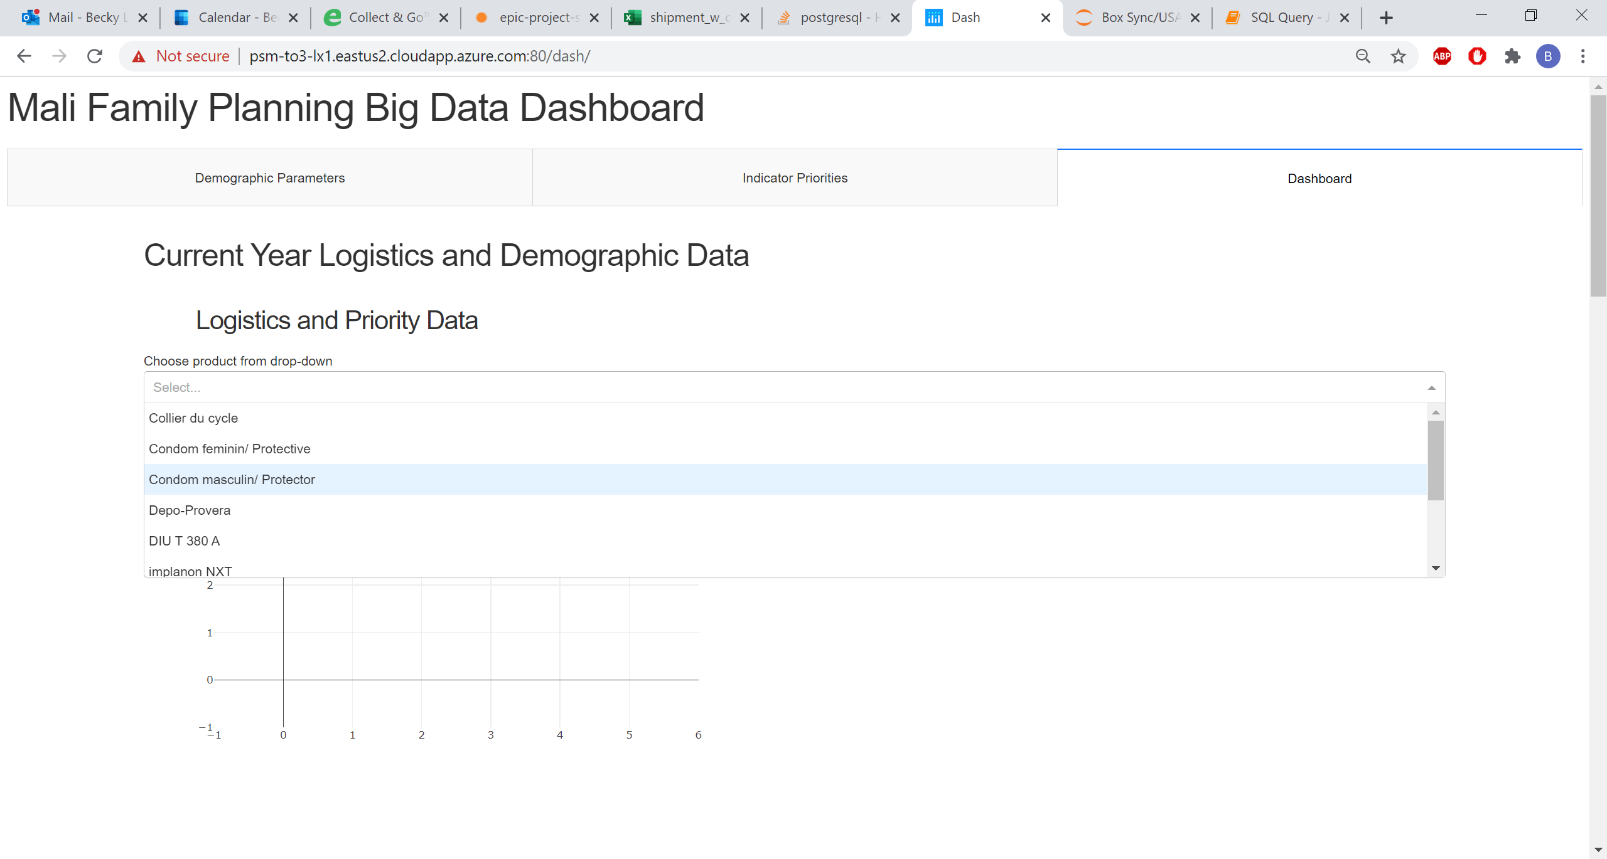

Figure 6. Product selection dropdown under logistics and priority data

Once a product selection is made, 4 visualizations will populate. The first one is a scatterplot of total priority score against inventory turn rate on the district level. Based on the latest selection of demographic indicator threshold and ranking, a priority score is calculated for each district; and based on the product selection, the inventory turn rate is calculated by product. Since inventory turn rate is a point-in-time statistic, the visualizations will use the turn rate from the last available month. The points are color-coded by region. The user can hover over a specific point to see district name, inventory turn rate, and priority score. It is worth noting that for each graph generated on the application, the user can use various controls to zoom in and out of the graph or download the image as a PNG file.

The second visualization is a table of the district-level turn rate scatterplot. By default, the table is sorted by priority score, with highest priority districts on top. The user can change the sorting by clicking on the arrows before the column names. An example of the two visualizations are shown in Figure 7.

Using these two visualizations, the user group are presented with highest priority districts. If these districts fall outside of the target zone, they should be of highest priority for actions. In Figure 7, which uses Depo-Provera as selected product, several of the high priority district fall inside or close to the target zone. There are also a few that have high turn rate and are at risk of stockout. Most of the districts have medium priority and have medium to high inventory turn rate.

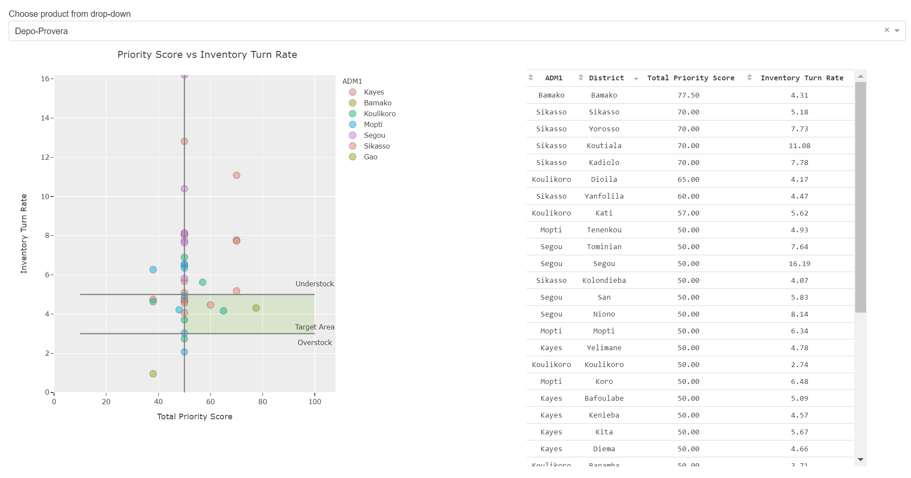

Figure 7. Populated scatterplot and data table

The third visualization shows inventory turn rate by region on a histogram along with a kernel density estimation plot. The fourth visualization shows a heatmap of the inventory turn rate by district for the selected product. The histogram shows that some regions have relatively flat distribution curve across turn rate ranges, others may have more extreme values. The two graphs are shown in Figure 8.

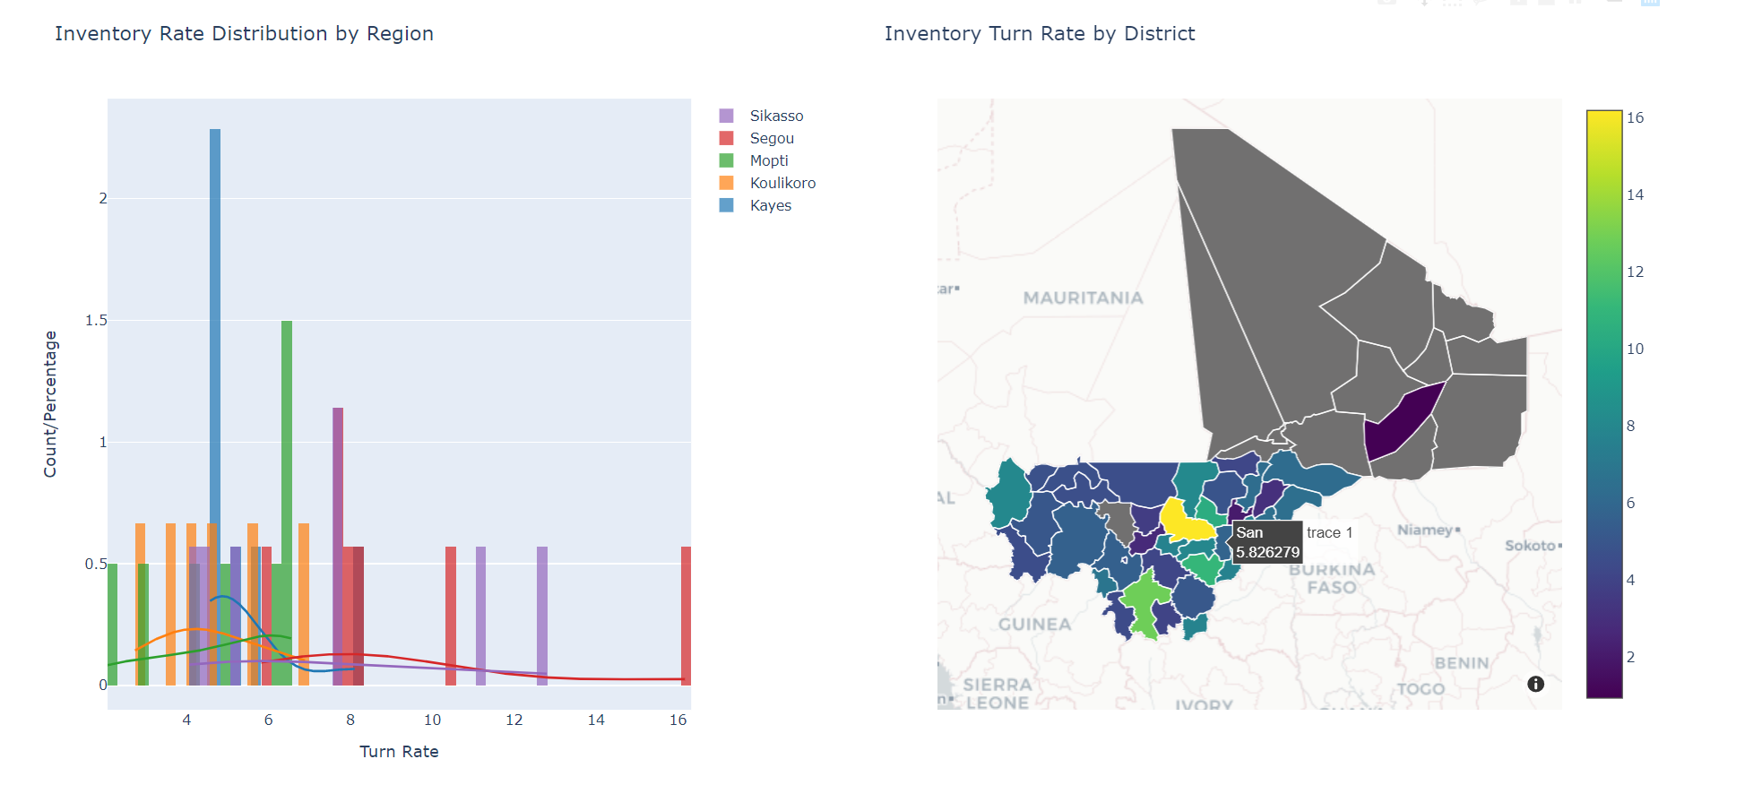

Figure 8. Distribution by Region and Inventory Turn Rate by District

Historical Logistics Data (2019)

This section has two visualizations analyzing 2019 logistics data. It requires the user to make two selections from the drop-down: product and region. The first visualization will show district-level inventory turn rate based on the selections by month. The second visualization is a scatterplot overlaid on a heatmap. The heatmap shows district priority score, and the scatterplot will show facility-level inventory turn rate.

Viewing the line graph across regions may reveal very different consumption behavior. Figure 9 and 10 show the historical inventory turn rate of Kayes and Sikasso for DMPA-IM. In Kays, the turn rate increases for almost all districts over the year, peaking at the end of the year. In Sikasso, the turn rate remains consistent over the year.

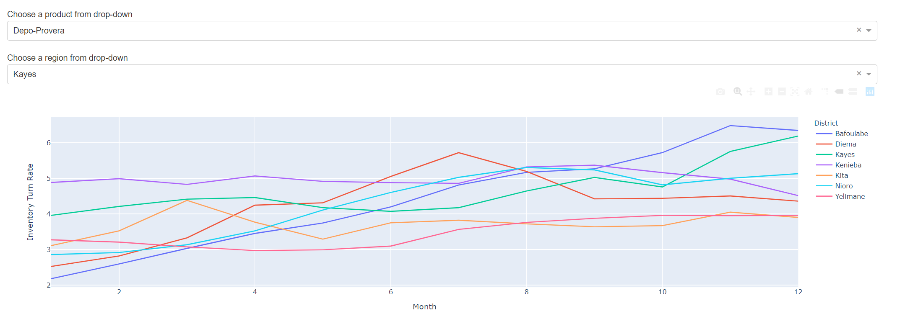

Figure 9. Depo-Provera inventory turn rate in 2019 for Kayes

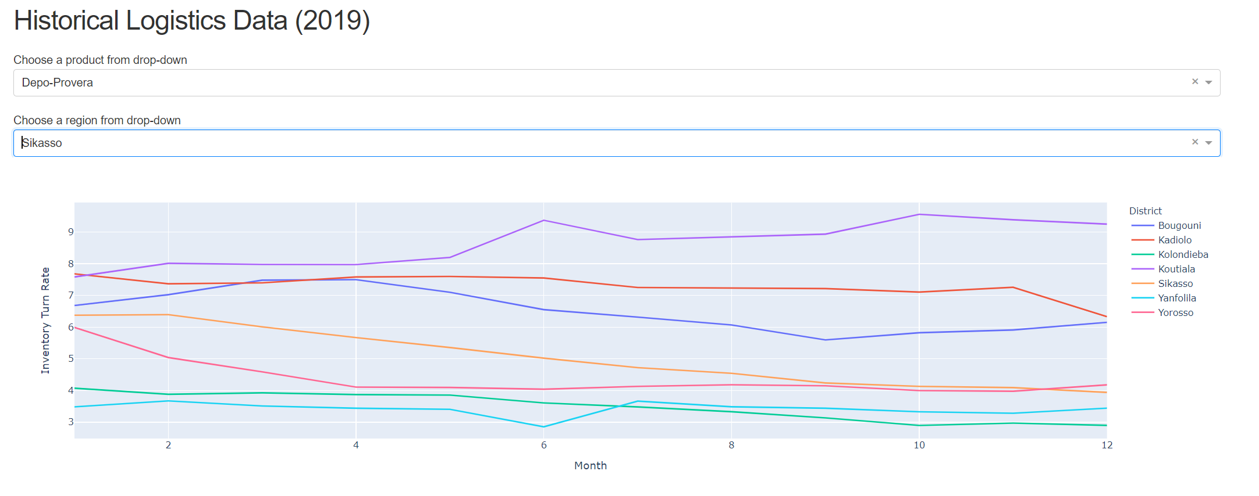

Figure 10. Depo-Provera inventory turn rate in 2019 for Sikasso

The scatter heatmap allows user to observe patterns across different regions of the country. Each individual data point represents a facility, and the user can zoom to the desired facility to review turn rate.



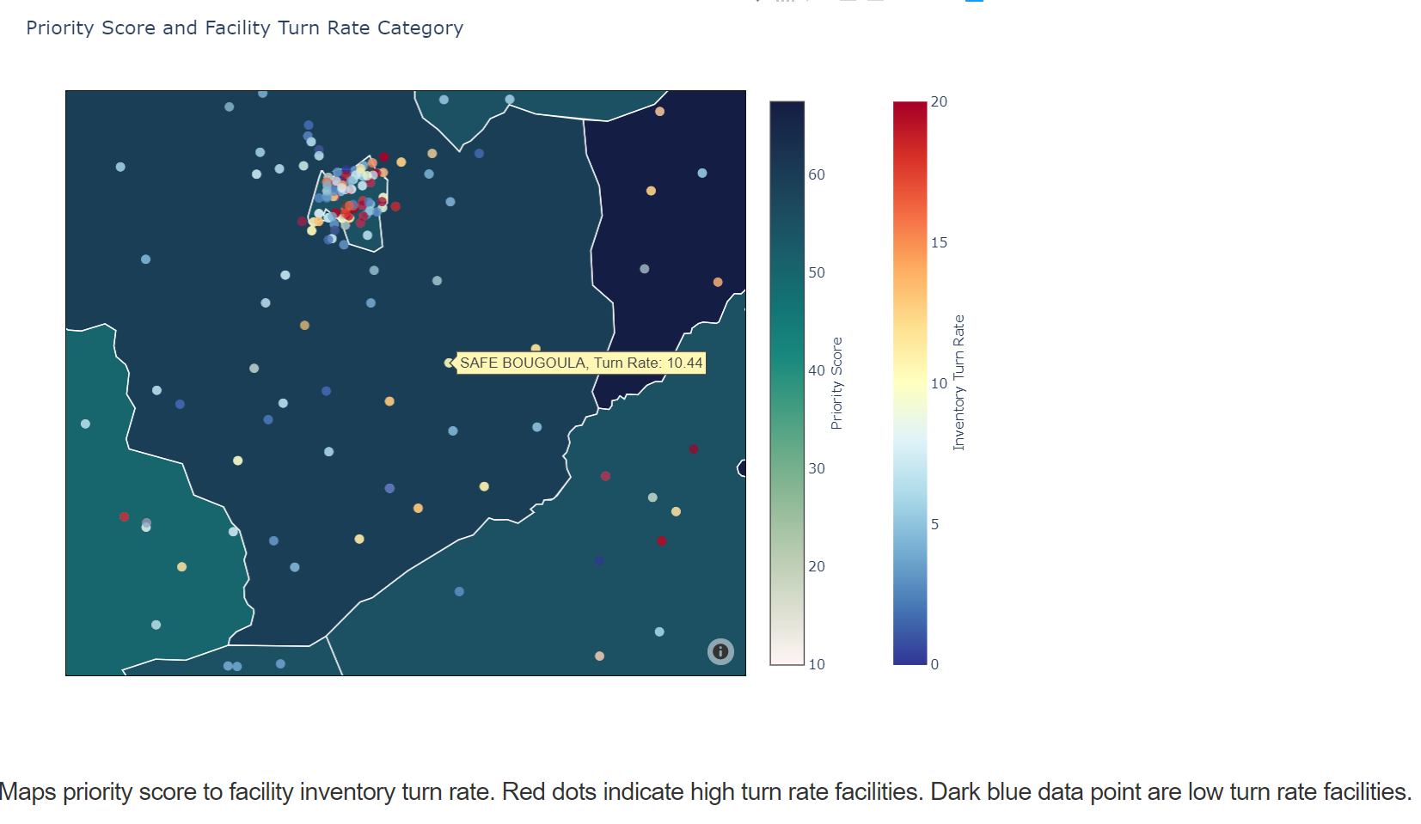

Figure 11. Depo-Provera inventory turn rate for a highlighted facility

Demographic Parameters

The last section on the dashboard tab is a heatmap of the demographic parameters. This is the same visualization in the demographic parameter threshold tab. Additional details are shown in section for Setting Threshold for Demographic Parameters. The placement of this heatmap is so users can review distribution by indicator without need to switch between tabs. Users may adjust the priorities, but this should only be done in a stakeholder meeting if the priorities are not aligned with the distribution data.

Annex A. Data Sources

Demographic Data

There are two sources of demographic indicator data: WorldPop and Demographic and Health Surveys (DHS).

WorldPop

WorldPop is an open-source geospatial research program that focuses on providing high resolution population mapping. The website publishes a myriad of WorldPop data is updated on an annual basis. This application uses data from 2020. It is the source for population and population density data.

WorldPop is also the source for pregnancies, which was last updated in 2015.

URL for population surface: <https://www.worldpop.org/geodata/summary?id=6399>

URL for pregnancy data: <https://www.worldpop.org/geodata/summary?id=1017>

Demographic and Health Surveys (DHS)

The DHS program collects data in areas such as maternal and child health, family planning, fertility, HIV/AIDS, malaria, and nutrition. It is the source data for geographical coordinates, family planning demand satisfied, family planning unmet need, and use of modern family planning methods. DHS data is not updated annually and was last updated in 2018.

URL for DHS: <https://spatialdata.dhsprogram.com/modeled-surfaces/#survey=ML|2018|DHS>

eLMIS data:

On a monthly or ad-hoc basis, a backend ETL process is set up to get data from Mali’s eLMIS database. This data will show on facility and product level, the stock on-hand, issues, and receipts by facility.